UNIVERSITY OF THE EAST

Rating
152 Samson Road, Caloocan City
College of Engineering
Information Technology Department

CCS2102 – OBJECT ORIENTED PROGRAMMING
Laboratory Activity 3

Name | RAMIREZ, Ishmael L. | Section: | IT2G
Student Number | 20201132141 | Professor: | Celis, J. R. E.

INSTRUCTIONS:
- For each problem, paste the code and sample output here.
- Make sure your name and student number are printed at the end of the output.

EXAMPLE:

Sample Problem:

Create a program that accepts two numbers, then displays the sum, difference, product, and quotient.

Code: Sample Output:
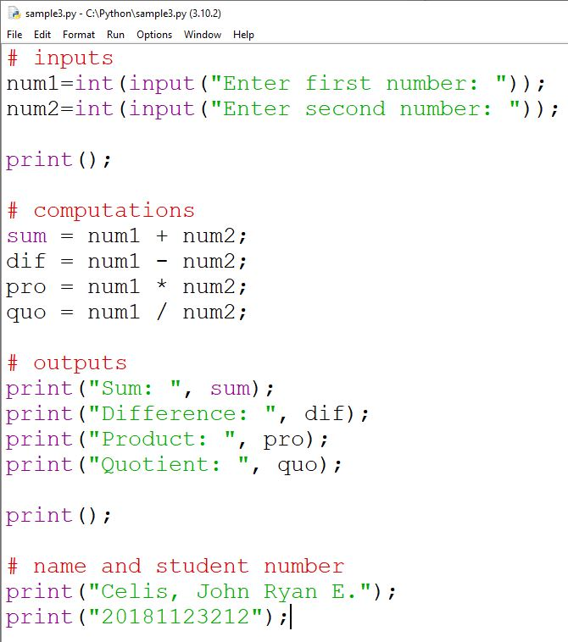
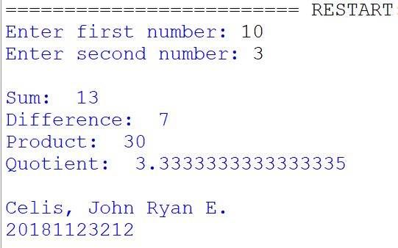

Problem 1:
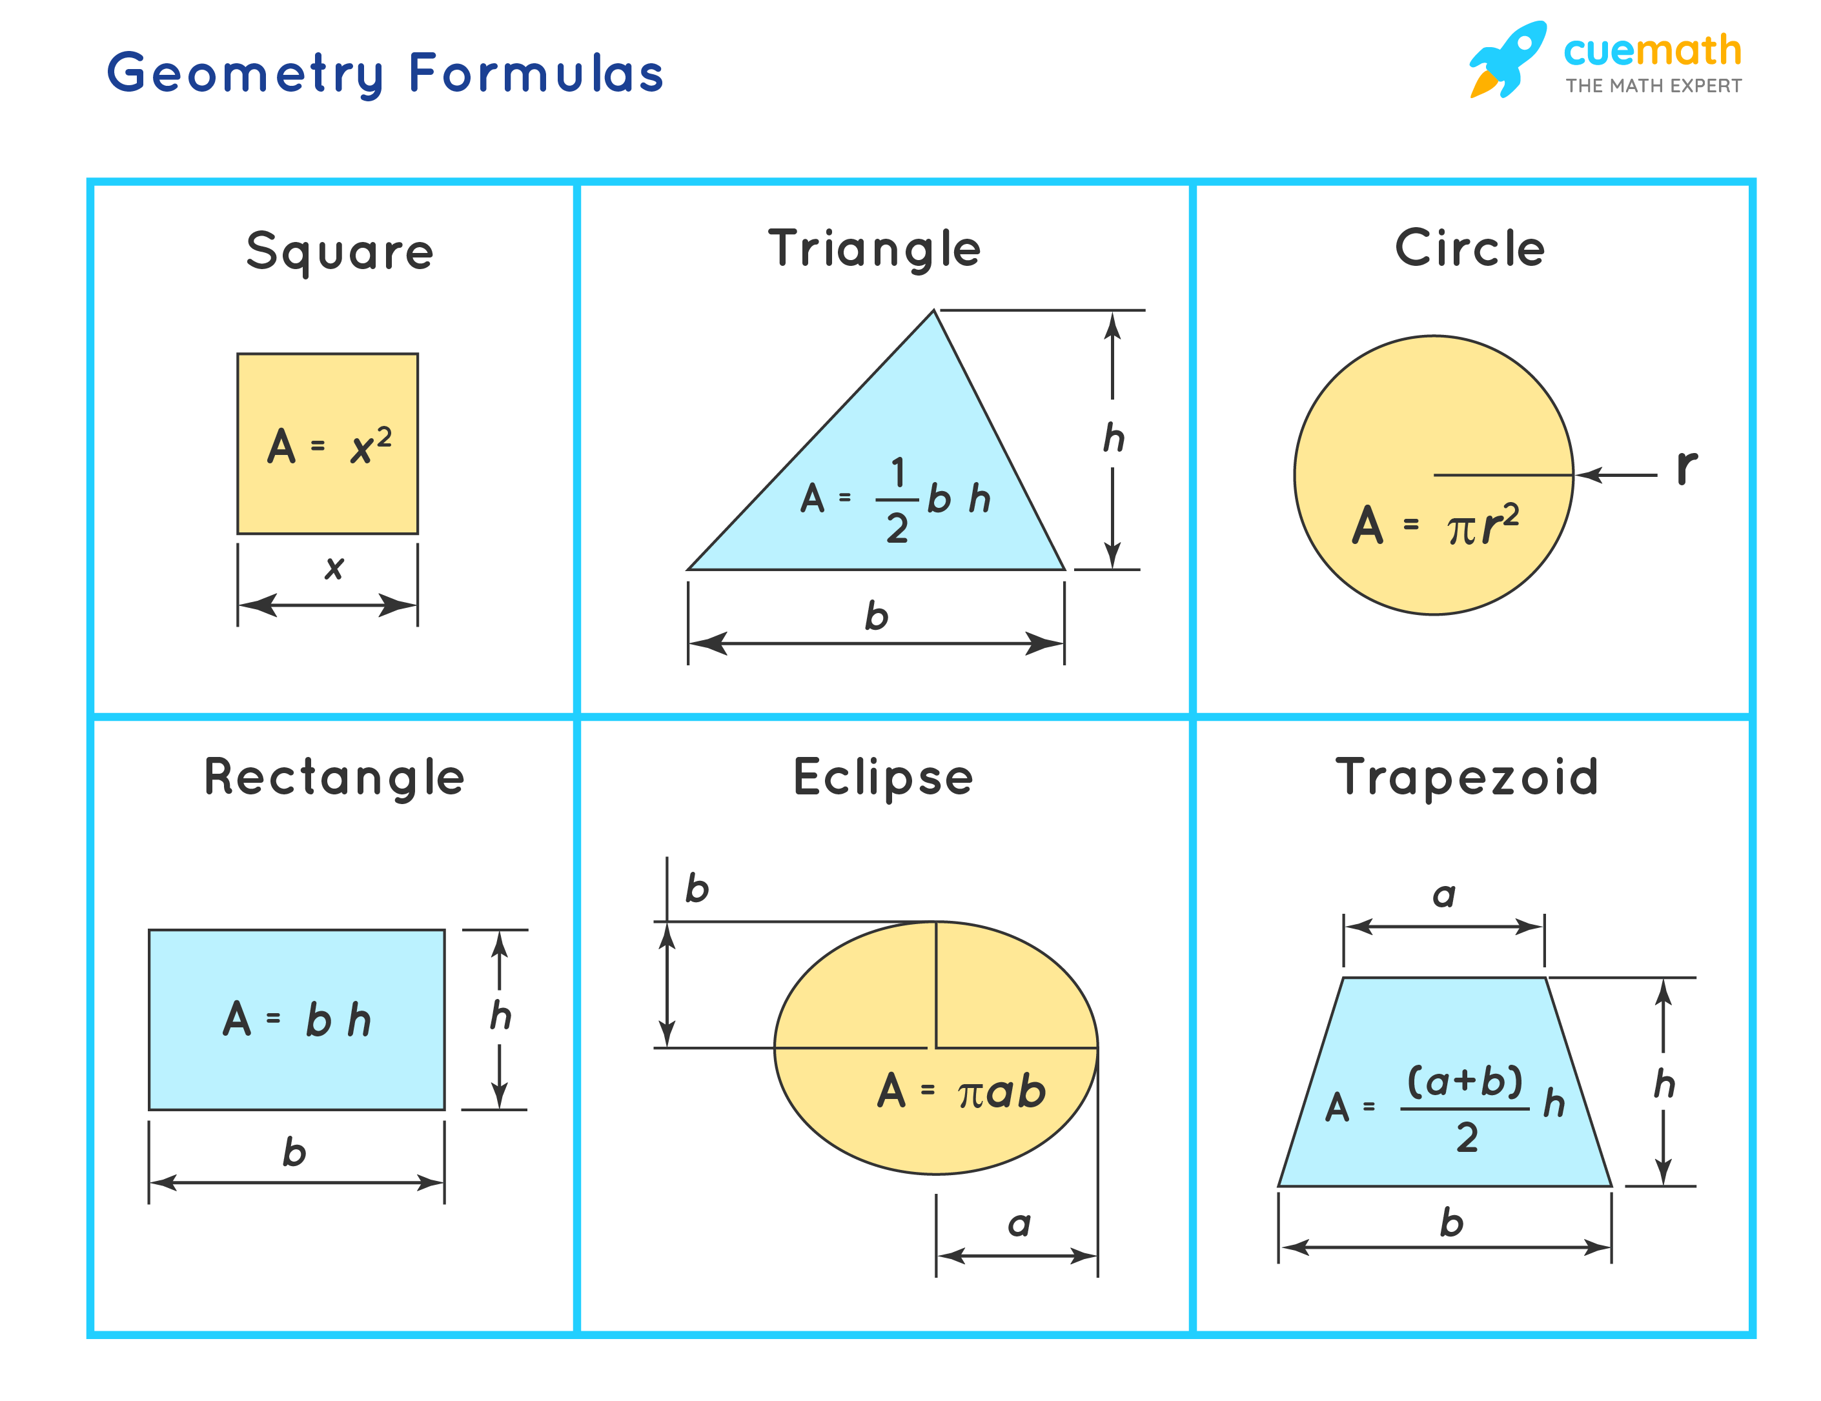
Create a C++ program that computes the area of a particular shape. Each shape has a different computation, refer to the image below:

Implement functions for each shape’s computation. Example if you chose 2, you should call the function that computes the area of a triangle.
Code:
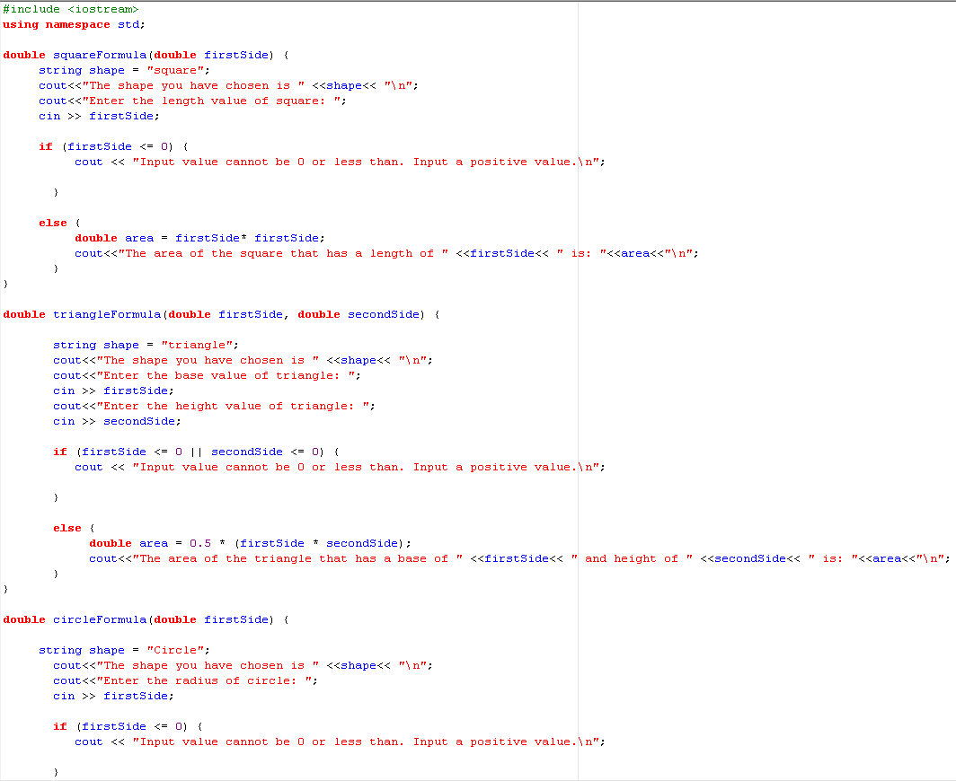
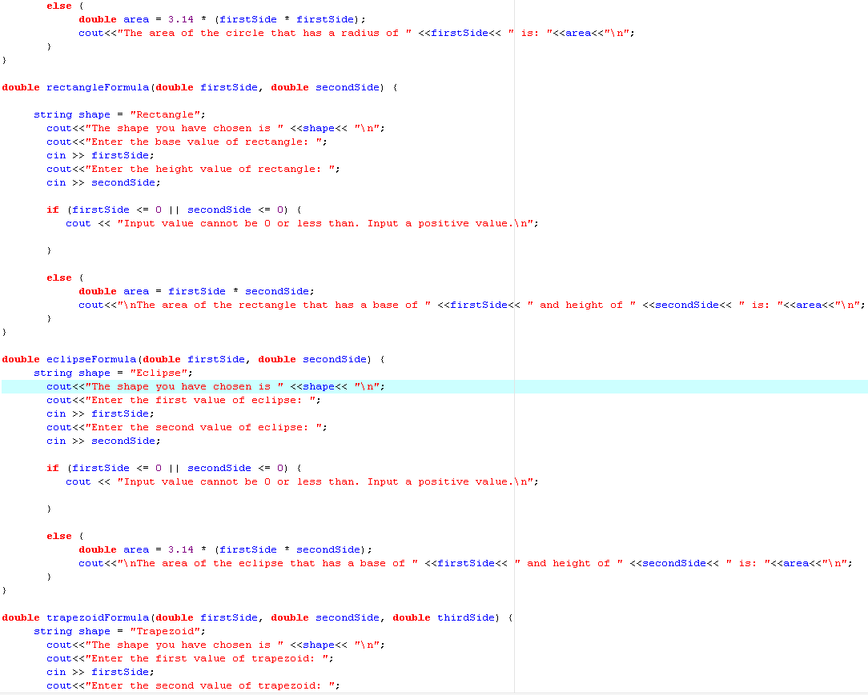

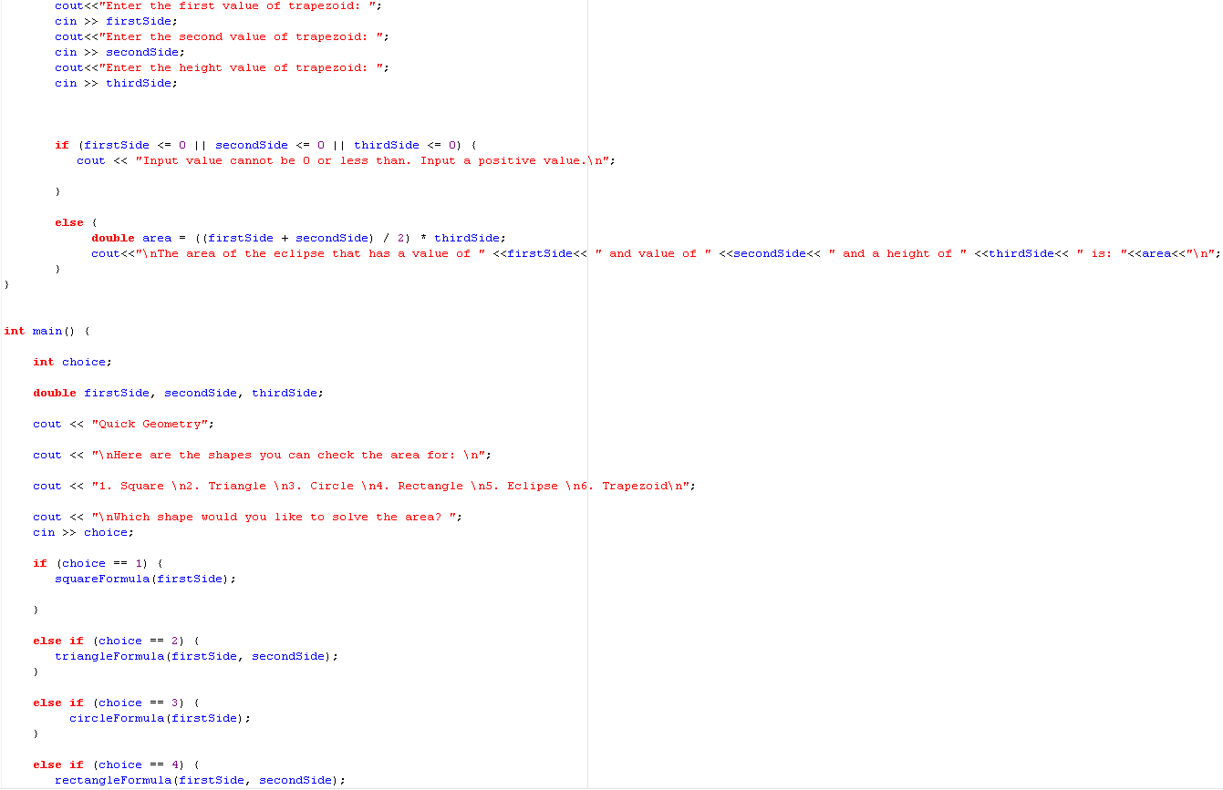

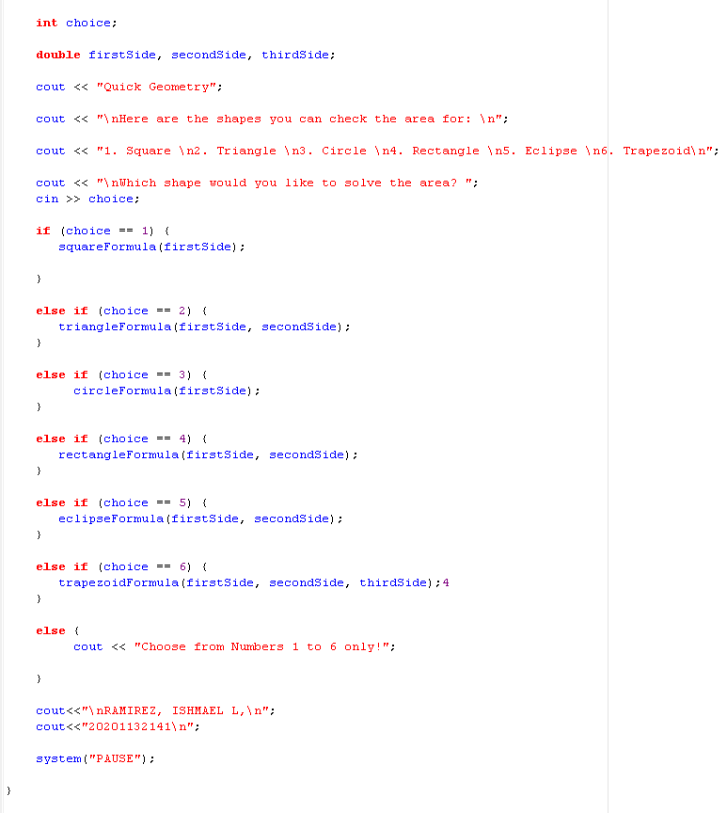

Output:
